Rebel Oil Company, Inc. dba ROC – Customer/Sales Representative Checklist
10650 W Charleston BLV., Las Vegas, NV 89135 – Suite 100 Phone: (702) 382-5866

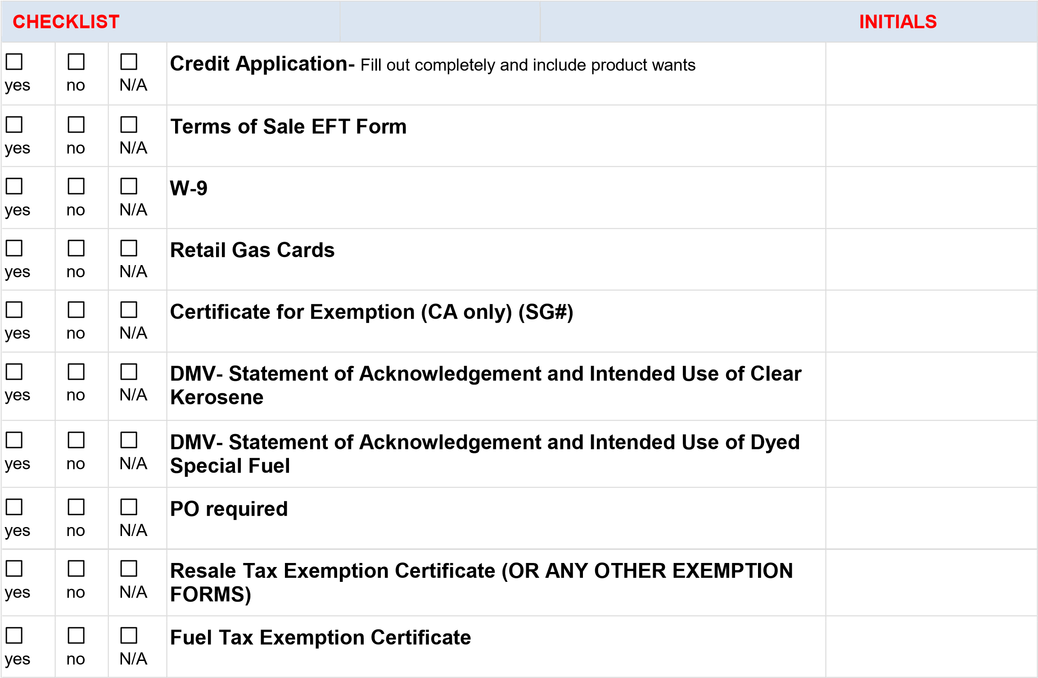

***** Failure to complete all sections of Credit Application will delay processing. *****

ROC Sales Rep.: _______________________________________ Approved ________ Denied _________

Credit Limit:__________________________________________

Date:____________________________________ By:_____________________________________

REBEL OFFICE NOTES: _____________________________________________________________________

__________________________________________________________________________________________

__________________________________________________________________________________________

Rebel Oil Company, Inc., 10650 W Charleston BLV., Las Vegas, NV 89135 – Suite 100 (702) 382-5866
The undersigned applicant is furnishing the following information for the purpose of procuring and establishing credit with Rebel Oil Co., Inc. d/b/a ROC.

Select Location:

LV Terminal: LV Warehouse: Hesperia: Kingman: Tonopah: Andy Devine: Dunphy/Elko: Price, UT: Midvale, UT:
Business Name:___________________________________ Contact: _____________________________
Address: ______________________ City: ________ ST: ___ ZIP: _____ FID#/SS# ___________________
Bill To Address: ___________________________________ CITY: ___________ STATE: ___ ZIP: _______
Type of Business: Sole Proprietor _________ LLC/Partnership____________ Corporation __________
Credit Limit Desired: $______________________ Fuel/DEF: Y/N Oils & Lubes: Y/N Tax Exempt: Y/N
Anticipated Annual Volume: _________________ # Years in Business: _________
Please provide copy of most recent Financial Statement and all Tax Exemption Certificates
Type of Entity:
Fuel Co____ Trucking ___ Mining ___ Construction _____ Farming ______ Railroad ______ Bus Co ______
Sovereign Nation_____ Fed/State/Municipal Agency _______ Other __________________

Owner, Key Personnel Contacts:
Name: ________________________ Title: ____________ Email: ________________________ Phone #: ________________
Name: _______________________ Title: ____________ Email: ________________________ Phone #: ________________
Name: _______________________ Title: ____________ Email: ________________________ Phone #: ________________
Bank Reference:
Contact: ____________________________ Email: _________________________________ Phone #___________________
Trade References:
Contact: ____________________________ Email: _________________________________ Phone #___________________
Contact: ____________________________ Email: _________________________________ Phone #___________________
Contact: ____________________________ Email: _________________________________ Phone #___________________
By signing below, I acknowledge, as an authorized representative of the Company, that the financial information provided represents a true and complete statement of Company’s financial condition and the above Bank and Trade references are authorized to release information to ROC for the purposes of establishing a Trade Credit Account with ROC.
Authorized Representative’s PRINTED Name: __________________________________________
Authorized Representative’s Signature: ___________________________________ Date: _____________________
Failure to provide complete and accurate information will significantly delay processing of this Credit Application

EFT CUSTOMER ENROLLMENT FORM AND TERMS OF SALES

Company Name: _____________________________________________________________________________________________________
SSN or Taxpayer ID#: _______________________________________________________________________________________________
Name of Banking Institution: _______________________________________________________________________________________
Bank Account Number: ______________________________________________________________________________________________
Bank ABA Routing Number: _________________________________________________________________________________________
Type of Bank Account: _______________________________________________________________________________________________
Bank Address: ________________________________________________________________________________________________________
Company Contact / Title: ____________________________________________________________________________________________
Company Contact’s Telephone Number: ___________________________________________________________________________
Company Contact’s Email Address: (for payment Notification) __________________________________________________________
Signature & Title of Authorized Corporate Official______________________________________ Date: ____________________
Customer hereby authorizes ROC to initiate electronic funds transfer debit and credits entries to Customer’s deposit account described below and does further authorize the financial institution described below to debit or credit such entries to the Customer’s account.

TERMS OF SALE

BULK FUEL – EFT Net 10 days, Oils & Lubricants – Net 30 days. CARDLOCK PURCHASES – Net 15 days ROC, at their sole discretion, reserves the right to modify terms from time to time as they deem necessary.
Applicant agrees that each of the terms and conditions of sale stated on this application shall be a term of contract Applicant and Rebel are parties to a written contract. Rebel reserves the right to apply interest if purchases are not paid within terms stated. Interest charges will be due and payable on the thirtieth (30th) day after the original invoice date and will be charged monthly thereafter if applicable. If any item is returned from your bank, a return processing fee of $100 will be applied. If Rebel commences litigation or employs and attorney in order to secure payment of any sum due to it from Applicant, the Applicant agrees to pay a reasonable attorney fee in addition to all other sums due the undersigned warrants that.
Signature of Duly Authorized Representative_________________________________________Title______________________
Printed Name of Signor _______________________________________________________________Date ________________________

